**Course: Advance Bio Informatics**

**Module Title: Gene Ontology (GO)**

**Module No: 73**

The Gene Ontology project provides ontology of defined terms representing gene product properties.

The GO covers three domains:

**1**. Cellular component (the parts of a cell or its extracellular environment)

**2**. Molecular function the elemental activities of a gene product at the molecular level, such as binding or catalysis)

**3**. Biological process operations or sets of molecular events with a defined beginning and end)

The goal of the Gene Ontology Consortium is to produce a dynamic, controlled vocabulary that can be applied to all eukaryotes even as knowledge of gene and protein roles in cells is accumulating and changing.

**GO (Objectives)**

It is a shared language for annotation of molecular characteristics across organisms. Mutual understanding of definition and meaning of words Cross DB queries. Members agree to provide DB access via common terms.

Gene Product Associations to an Ontology

•Is-a

•Part-of

•Subprocess of

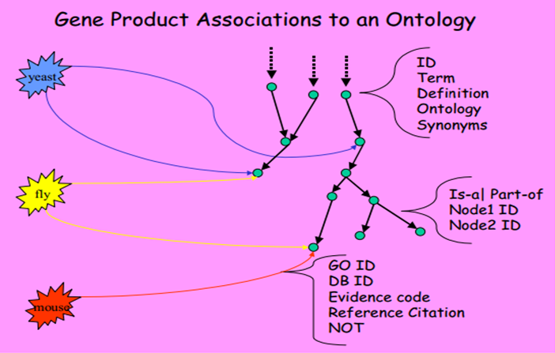

**Go Ontology**

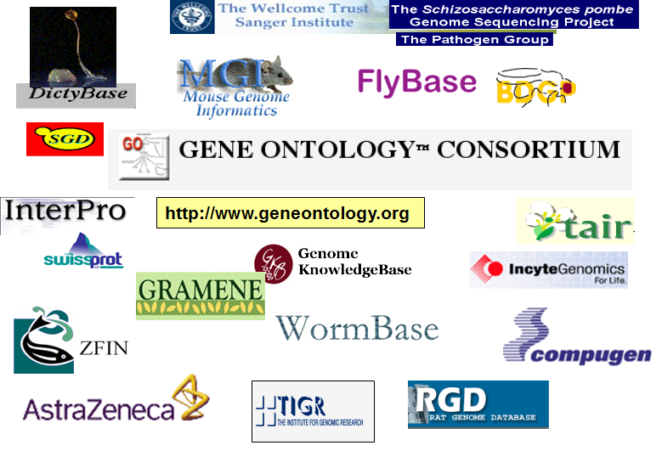

**Example**

Cytochrome c

**MF:** oxidoreductase activity

**BT:** oxidative phosphorylation and induction of cell death,

**CT:** mitochondrial matrix & mitochondrial inner membrane

**GO - Details**

Species neutral Terms applicable to prokaryotes and Eukaryotes (single and multicellular organisms). GO does not attempt to describe every aspect of biology; its scope is limited to the specific domains.